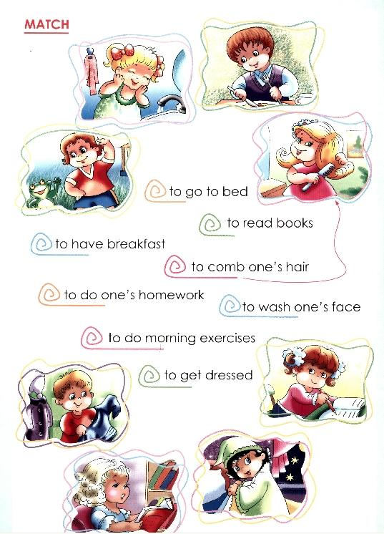
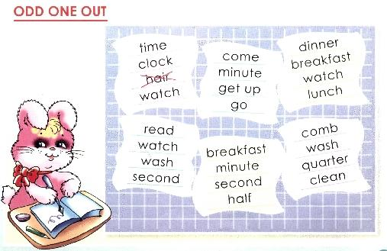

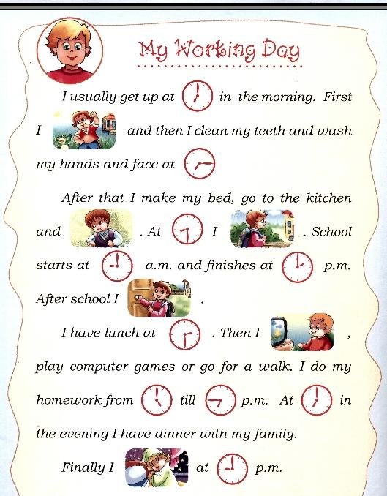
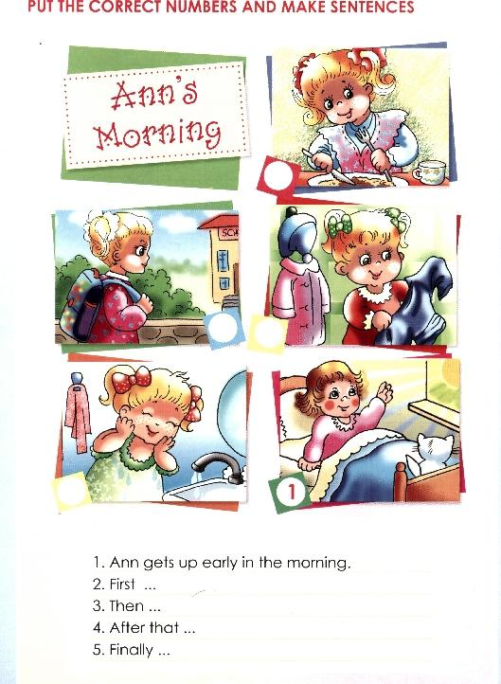

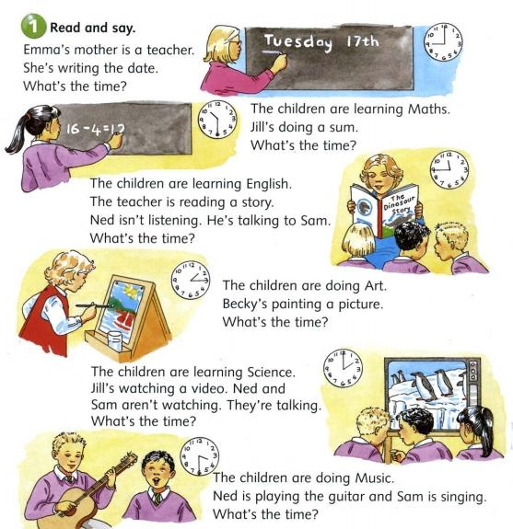

Dialogues
So. Lets imagine that one of you is famous film star. Ask her questions about what does she do every day.

Письмо

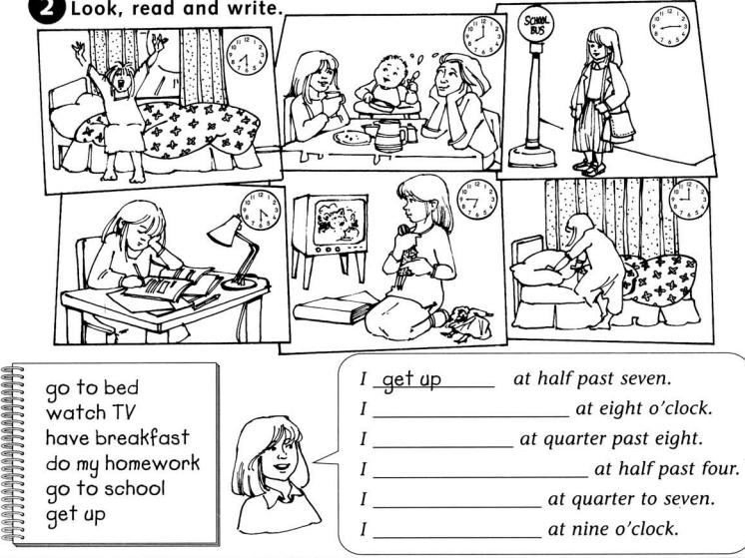

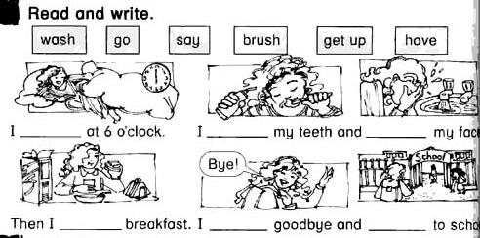

Teacher : I have got a letter from Robin Bobin. Now you will try yourself as teachers. You should check this letter and find mistakes, which Robin Bobin has made.

Hello.
My name’s is Robin Bobin. I’m am nine.
my favourite subject’s is English.
I’m from london.
I get up at 6 o’clock. I take a breakfast. I clean my face and wash my teeth.
Then I dressed and have school at 7 o’clock.
Then I go to shop.
At 5 o’clock I do my homework. In the evening I watch TV and play. I go to bed at 9 o’clock.

Задание на доске: раскройте скобки.
1. Helen _____ her mother about the house yesterday (helps, helped, is helping).
2. We _____ to New York last year (aren’t going, don’t go, didn’t go).
3. I _____ a shower yesterday morning (took, am taking, take).
4. Kate _____ dinner at school last Friday (had, is having, has).
5. We _____ in the swimming pool last summer (aren’t swimming, don’t swim, didn’t swim).
6. I _____ my morning exercises yesterday morning (do, am doing, did).

– What time did you get up yesterday?
– Did you do your morning exercises?
– Did you wash hands and face yesterday morning?
– Did you take a shower in the morning?
– Did you dress yesterday morning?
– What time did you have breakfast?
– What did you have for breakfast?
– What would you like to have for breakfast?
– What time did you go to school?
– How many lessons did you have at school?
– What would you like to have for lunch?
– What did you have for lunch?
– What time did you come home?
– What time did you have dinner?
– What did you have for dinner?
– What would you like to have for dinner?
– Did you help your mother about the house?
– Did you do you homework?
– Did you go for a walk?
– Did you watch TV?
– Did you skate yesterday?
– Did you ski yesterday?
– What did you have for supper?
– What would you like to have for supper?
– Did you play chess?
– What time did you go to bed?

Развитие навыков аудирования
Teacher: Well, children, here is a surprise for you. Our school has got a taped letter from a girl who lives in America, in New York. Your task is to listen to her story attentively and to answer my questions. She will be telling us about her day and the food she eats and likes.

“My name is Jenny. I’m from New York. I’m a pupil and I go to school. Yesterday I got up at 6 o’clock. I didn’t do my morning exercises, but I took a shower. I cleaned my teeth and washed my face and hands. Then I dressed and had breakfast at 7 o’clock. I had porridge, toast and eggs, with a glass of orange juice for breakfast. Then I went to school. I had 7 lessons at school yesterday. So I came home at 3 o’clock and had dinner. At 5 o’clock I did my homework. I didn’t go for a walk yesterday because I helped my mother about the house. In the evening I watched TV and played chess. I had supper at 8 o’clock in the evening. I had meat and potatoes, fruit and a glass of milk for supper. But I would like to have ice-cream, bananas and hamburgers for supper. I went to bed at 11 o’clock.”

Questions:
1. What time did Jenny get up yesterday?
2. Did she do her morning exercises?
3. What time did she have breakfast?
4. What did she have for breakfast?
5. How many lessons did she have at school?
6. What did she have for dinner?
7. What time did she do her homework?
8. Did she go for a walk yesterday?
9. What would she like to have for supper?
10 . What time did she go to bed?

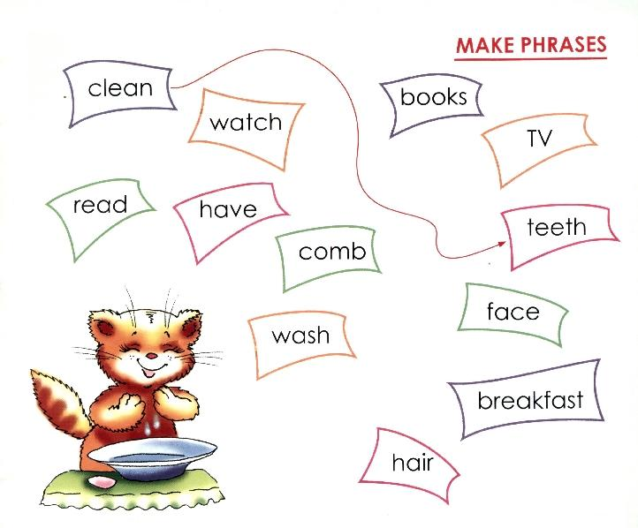

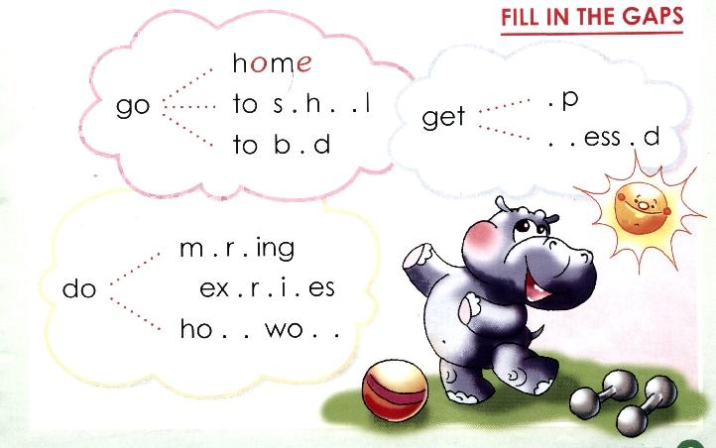
Lets give this hippo name! how old is he? Tell

